Strategic Marketing Model – A Usable Model
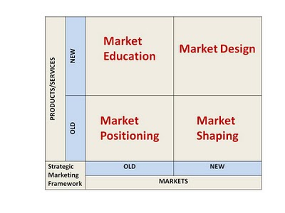
We present below a simple strategic marketing model that can be used by all – MNCs, big businesses, SMEs and even start-ups
The two dimensions of this model are
1. Product/Service that you want to launch - is it NEW or OLD?
2. Market that you are targeting - is it a NEW Market or an OLD Market?
If you launch an Old product/service in an Old Market ` You have to think about Market Positioning as the market already has many such products/services - You are one more player in a crowded space. This is also a RED OCEAN. Example ~ you have to launch a SHAMPOO for Urban population.
If you launch an old product/service in a New Market ' You have to think about Market Shaping. As the market needs to adapt to your product/service, you have to create your communication to illuminate how your product/service can replace the existing way the market performs particular functions. This should include your successes in other markets. For example, if you have vacuum cleaner that you need to introduce in say rural India, you need to shape the communication so that market get to know how other markets in say other countries have used vacuum cleaners and how these have been say, more effective per unit cost. When Volvo introduced its buses in India, their initial cost was much more than other options available to bus operators. But they designed and showed – the Total Cost of Ownership (TCO) and customer convenience to me order of magnitude more than the existing methods.

If you launch a new product/service in an old market - you need to get into Educating the Market. An old market views your company with the existing products and services that you are providing. The mapping of your company brand with the products/services is very strong. If you introduce a new product/service that is different from what you have been providing, it is extremely difficult for the market to get the embedded image of your company washed and replaced by the new product/service. Educating the market requires you to create an intellectual distance between your old product and new product. This will need very sharp communication design.
Finally, if you are launching a New Product in a New Market - It is an Inventive process/ Design process - you need to Invent/Design the Market. The market has to be created by explaining to and employing early users. Here, key opinion leaders, iconic figures; celebrities may come into picture in your communication. This simple Strategic marketing model is immediately usable and can be deployed in your thinking quickly.

Navneet Bhushan (Navneet) is a founder director of CRAFITTI CONSULTING (www.crafitti.com) – an Innovation and Intellectual Property Consulting firm focused on co-crafting Innovation in global enterprises. He is the winner of Indira India Innovation award for Entrepreneurship and Innovation Leadership for 2012. He is the principal author of Strategic Decision Making- Applying the Analytic Hierarchy Process published by Springer-Verlag, UK, as part of the Decision Engineering Series. Navneet Blogs at http://innovationcrafting.blogspot.com. He can be contacted at navneet(dot)bhushan(at) crafitti(dot)com

