THE GIX Bang World – The Globalizing Innovation Complexity

The Emergence of a new World

It is remarkable that two important violent events separated by the decade that ushered us to the new millennium have been the catalysts in defining and shaping the world that we have been calling globalization. When Iraq annexed Kuwait in August 1990, it was considered a defining moment of shift from cold war of bipolar era. January 1991 Gulf War – operation desert storm and unique ways in which it was conducted by the United States resulted in multiple experts proclaiming the start and application of a Revolution in Military Affairs (RMA). The unprecedented interplay and cohesion obtained by integration of precision technologies, networks, and information technologies was a remarkable demonstration of extent to which new military operations will depend upon knowledge and networking. This was a shocking surprise to military commanders who were still indoctrinated in the old ways of mass destruction and mass combat power to defeat massed armies.

Ten years later it was the turn of the have-nots to attack the very seat of economic power represented in the twin-towers of the world trade center thereby reducing it to rubble. The permanent etching that Osama Bin Laden has left in the world’s especially US psyche despite the powerful US defense forces perfecting the RMA’s that they created, has once again reiterated the power of knowledge and networks. The way September 11, 2001, was executed against the most powerful nation of the world, speaks of three main capabilities – Globalization, Innovation, and CompleXity.

It took another decade and trillion dollars for US to kill the icon of terror and chief of notorious Al-Qaeda - Osama Bin Laden. The two decades on both sides of the millennium change starting from sudden demise of Soviet Union and immediate 1991 Gulf-war and ending with neutralizing OBL in Abbottabad in 2011, defines the new world that definitely has changed the pace, politics and people that inhabit it in more fundamental ways than we ever had before in in a short span of 20 years.

It all started about 14 billion years ago – when space and time had no existence and the universe was what is called a singularity – a compressed dot of extreme density that exploded with such a force that it not only created sub atomic particles but a universe that from all scientific evidence is still expanding. The chronology of events that resulted in the massive explosion Cosmology theorists combined with the observations of their astronomy colleagues have been able to reconstruct the primordial chronology of events known as the big bang.

The three violent events starting with Gulf-war, 9/11 and OBL neutralization are just a sample, albeit with very violent results, of the interplay of the three capabilities of the new world. This world is based on the ability of each one of us to leverage and exploit knowledge and connectivity. Success in this new world requires ability to search for knowledge, create new knowledge, identify the knowledge pieces, convert these pieces into creating new value in terms of solutions, and flow it through the networks of globalizing world in an efficient manner so as it reaches the site of the problem in space and time in a least wasteful manner. The massive pace of globalization, innovation and complexity that we are seeing in last 20 years indicates a new big bang – a massive change – I would like to call it the GIX (Globalizing Innovation Complexity) Bang world.

There seems to be fundamental shifts that are shaping our lives.

Characteristics of the GIXBang World

We are living in a rapidly globalizing world. In this shifting world, rules of the game can change anytime; success will come to those who adapt quickly to the new rules. And as is common understanding, the best way one can adapt to the new rules is by writing these rules. In these highly evolving times, with extreme uncertainties and time compressions, it is the successful exploitation of ideas, i.e., Innovation, which can be the only competitive advantage. The new globalizing world is characterized by rapid change. One may argue that change is the only constant in our world anyway, however, the pace of change in the globalizing world enabled by technological advances in multiple dimensions, requires understanding and responses that are unprecedented. The characteristics of the new world are:

Global Real-time Awareness – 9/11 depicted a remarkable feature of the new world. Besides the fact that it was a horrific event in terms of its impact on world psyche – it characterized the feature of the new world where events are beamed live in our living rooms. As the aircraft hit the second World Trade Center (WTC) tower, one could feel and see what was happening. This real-time awareness of what is happening across the globe to an individual enables the individual to form his/her own opinion very quickly, and respond. This capability and knowledge available to an individual in real time creates a speed up in actions that is unprecedented.

Collaboration with Competition - This is the age of simultaneous collaboration and competition. Many a times synergy in value creation is possible when one starts collaborating with one’s competitors and sometime one may need to compete with one’s collaborators. Collaboration is a much higher activity involving cooperation and elaboration rather than cooperation alone. It is the age of co-creation.

Power shifts to Knowledge Based Real-time Innovators – Power, i.e., ability to affect a change, has become more knowledge-based rather than based on violence or wealth alone. However, speed is the new mantra in the globalizing world. Coupled with a bias for action, indicates that power is shifting to innovators who act in real-time and base these actions in knowledge. This is a complex feature of the new world. Actors who manage this complex interplay of knowledge, innovation and speed to affect or adapt to changes, are creating the success stories in the new world.

A Fully Connecting World – The new world is characterized by network form of organization, which is favored by the information revolution. It is the most modern form of organization structure, successor to tribes, hierarchies and markets. However, multiple organization structures compete for their adoption in the globalizing world. Hence the networked form is integrated with other forms to create hybrid organization forms. The new world needs an organization structure more closely mapped to the network form. Many large enterprises are struggling to come to grips with this change, which requires fundamental shift in the organization structure. Although many enterprises have successfully made this transition, however, the thinking of the people/leaders continues to be hierarchical rather than networked. The new world will need a rapid shift to networked thinking in the organizations.

Barriers Demolished – Technological advances have demolished the shackles imposed by time, trade, space, geography, culture, language, societies and even history - as people realize the power of connections or networks. This is creating a Global village where everyone seems to know about every event in all parts of the world. This is a tremendous capability to have in a world of positive energy. However, these networks can drag the world into negative arc of destruction and demolition if the “have-nots” of the new world start leveraging the new found freedom to form networks of destruction. The disconnected in the globalizing world are left out. These disconnected may become disgruntled and either may die out or may resort to disruptions. Enterprises that remain disconnected need to quickly connect and become part of the change rather than the victims of the change.

Survival of the Agile – Quick decision making and action as quickly as possible is helping organizations adapt and survive. There is a need to have organization structures that help in creating and deploying agile decision making processes.

Individuals Empowered to continuously re-invent – An individual has been empowered to adopt and adapt to new ways of doing things. This enhances his/her learning and ability to respond to multiple stimuli in much more organized and innovative ways. Enterprises need to enable this continuous re-inventing capability to each of its employees else it is obvious that employees will find avenues outside to re-invent themselves.

Complexity of the GIXBang world - The connotation of difficult or hard to describe leads to a system being viewed as complex. Complexity has been defined as two or more distinct parts that are joined in such a way that it is difficult to separate them. This characteristic of complex system led Ray Kurzweil, the author of “Singularity is Near”, to state “I know English but none of my neurons do”. Complexity generates an emergent behavior that is not exhibited individually by any of the parts, partially or fully. Further the connotation of difficulty in understanding this emergent behavior of complex systems springs from our classical methods of thinking. These methods have proven their worth in tackling the issues of classical science, problems and issues predominantly in a world of distinct organization structures where the interactions between uniquely identifiable elements were clear and unambiguous but relatively few and limited to specific dimensions. These methods were based on reductionism or analysis, determinism, dualism, correspondence theory of knowledge and rationality. However, the classical methods of dealing with mechanical systems and mechanistic worldview pioneered by Aristotle and taken to their zenith by Newton, faltered in explaining the new observations that started coming in early parts of last century. Further, the lessons from complexity research initiated a worldview that real world is not the perfect, geometrical, ordered, predictable, deterministic, rational construct that human mind, labor and ingenuity has created by engineering perfect geometries that we see in all man-made physical structures. The nature turned out to be an extremely creative and complex system, where dynamism and emergence are the norms. It is with deeper study of nature of information; man started realizing the inherent complexity of the world that is unfolding.

Embracing Complexity - We do not understand complexity. This is an inherent property of reality and the nature shows umpteen examples of the complex behavior as exemplified in the emergence of order in various seemingly simple, local interactions with limited rules in various natural systems. Complexity emerges from dependencies – informational, control, decisions, structural and material dependencies. Connections create complexities as well. Multi-dimensional dependencies create higher order complexities. How can one embrace complexity rather than thinking or working for reducing complexity? How can one invent or innovate to leverage the boundaries rather than always focusing on the core? It is at the boundaries that value capture will have maximum returns. Value capturing and value creation are interrelated phenomenon that one needs to maximize.

Artificial and Natural Complexity - Complexity is not necessarily natural; in fact most prevalent form of complexity impacting human-beings is artificial. The artificial things are synthesized by human beings. The world around us is full of more artificial things than natural things. Starting from our morning alarms, newspapers, radio music, television images and computer chat rooms – we work through artificial things till the night when we sleep in artificially heated rooms and beds. The design of artificial things, even though playing such an important role in our life, does not consider the complexity these things create in our life. The artificial has become more of a norm than natural for human beings (at least in the so called developed world) thereby creating layers of complexity that get enmeshed and intertwined in our life that we cannot separate the artificial from us without seriously jeopardizing our so called civilized existence.

Further unlike natural systems that may evolve because of specific constraints or available paths, the artificial systems are designed at least in principle, with a specific goal or function in mind. Further as Herbert Simon, in his book “Sciences of the Artificial”, describes, an artifact to be an interface between inner environment and the outer environment. The artifact tries to accomplish a goal or provide a function in the outer environment. This artifact can have one of many possible internal environments to accomplish the same desired function in the same environment. This is an important fact, as it indicates that theoretically infinite ways exist to construct or design an artifact to accomplish specific function in specific environment. This is important; because this fact creates an uncertainty and unpredictability, in the artificial world that we are living-in as it leads different actors to design different artifacts to achieve the specific function in multiple environments. This is a dimension of complexity that needs to be understood and grappled with.

The interplay of natural and artificial is another area that comes under the realms of complexity. Natural objects evolve through natural selection and based on the environment in which they operate. The observations based on how the natural phenomena occur led humans to fields of natural sciences. The industrial revolution started a clear direction towards the artifact sciences where suddenly man-made objects became prevalent and useful with specific functions or goals to be achieved in specific environments. Modern world characterized by artificial environments, virtual reality and synthetic materials, has become more man-made than natural. Yet nature has not been tamed fully – in fact nature’s fury keeps on giving clear messages of the journeys that humankind has yet to perform, in the form of earthquakes, hurricanes, floods, volcanic eruptions and multiple natural disasters that happen in many parts of globe.

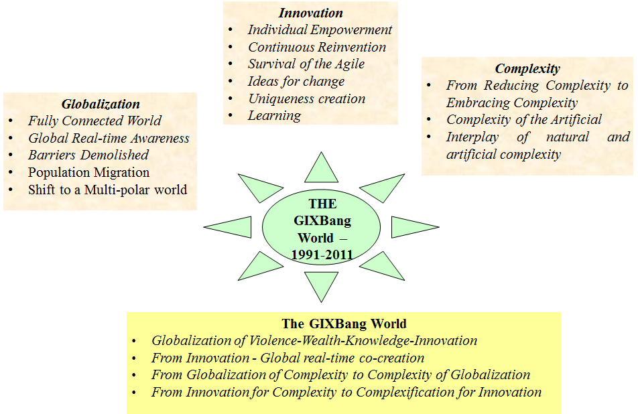
Problem solving by Complexification - Problem solving methods have always looked at how to reduce the problem into smaller pieces and then solve the part problems. This has served the science and technology through the ages. The complexification as a method of solving problems is the other extreme. We are discovering that sometimes more complexification may actually help solve problems. Systems are designed to achieve functions. Can systems be designed so that functions (new functions) emerge from the working of system(s). Emergence of higher order functions, i.e., emergence of complexity is akin to emergence of life – although may be at much lower order of, well, complexity. How to design systems, or system of systems, to let new functions emerge? We are not only asking these questions but are already taking more than baby steps towards realization of such capabilities.
The increasing complexity – either natural, artificial or a combination of both – is an important fact of the new world. The increasing globalization is creating more complexity as is evident in multiple dependencies, connections and unknown network effects the globalization pace is creating for humankind. Yet there is hope – it is remarkable how much human mind is able to create and synthesize especially in last 100 years or so. In fact, there is no gainsaying that artificial future is more likely than a natural future – at least next 50 years or so. This is possible and thinkable only because of the human mind which has proven to be an extremely robust and comprehensive factory of new ideas, new thoughts and new memes that are successfully implemented to create artifacts, synthetic environments, and robust global artificial systems. This is the dimension of Innovation – which we defined as successful implementation of ideas.

Innovation – the Success in GIXBang world

Innovation is the key. Further it is not Innovation in your home, your country or your organization. It is Innovation through open collaboration with the whole world. This requires a monumental mind shift by all. The inertia of what we have learned through multiple centuries requires a rethink to wash away the legacies of disjoined, protected, war ravaged, holocaust ridden, race-exploited, and hatred filled memes that our minds have inherited. This requires counter-intuitive tools, methodologies and frameworks coupled with new strategies and vision to make the new world a success. We need frameworks as a coupled blue print to craft and leverage innovation by co-creation. This is the fundamental need of the new world and basic component of success in rapidly globalizing world.

Innovation for the purpose of this article will be defined as “Successful Exploitation of (New) Ideas to create the desired change”. These ideas (New or old) can come from other industries, our competitors, our employees, our customers, our suppliers, or anywhere else. To identify and generate new ideas organizations need new methods to overcome psychological inertia of core competence. Further new methods are needed to overcome limited knowledge that individuals and organizations have. What we know is limited by what we can know today; what we don’t know today is what we will be forced to know tomorrow; what we should do is to create as many alternative futures as possible and also keep with us as many possible histories as possible. We don’t know which history is connected to which future – but one path is unfolding right now – we need to find out which one. More important is we have the power to create and choose paths that are not evident overtly. This leads us to questions that need answers and trends that we need to take into account for Innovating in an increasingly globalizing complex world.
Innovation has four phases, (a) Ideas (may remain in mind or may be expressed) (b) The way the idea is implemented (c) the context (different) in which the ideas are implemented (d) the (different from past) results it has produced. The uniqueness can be in any of these four phases. However, all four phases need to be there for Innovation. Just to distinguish between creativity, problem solving and design, we shall follow that creativity is the process of generating something new. Problem solving is the process required when we seek some kind of a resolution, such as removal of a drawback or achievement of a specific enhancement or improvement. Problem solving usually includes creativity as a part of the process. Design activity is necessary when we are dealing with any kind of a system (read structure to achieve a function) creation. The design process can include problem solving and, if necessary, creativity. Innovation for our purposes will include all the three activities and decision making. We define decision making as a choice amongst a set of alternatives. The focus during creativity, problem solving and design are human mind, specific problem and specific function and structure of the system, respectively.

Since human brain/mind is central to creativity and innovation, it will be interesting to review what human brain is at this point. What are the key learning principles followed by human brain? As we know, the brain can be considered as a complex adaptive system. The brain is a social brain. The search for meaning is innate. The search for meaning occurs through patterning. Emotions are critical to patterning. Every brain simultaneously perceives and creates parts and wholes. Learning involves both focused attention and peripheral attention. Learning always involves conscious and unconscious processes. We have at least two ways of organizing memory. Learning is developmental. Complex learning is enhanced by challenge and inhibited by threat. Every brain is uniquely organized.

Three Conditions for Learning
- "Optimizing the use of the human brain means using the brain’s infinite capacity to make connections–and understanding what conditions maximize this process." Three interactive and mutually supportive elements that should be present in order for complex learning to occur are:

  - An optimal state of mind that is called relaxed alertness, consisting of low threat and high challenge.
  - The orchestrated immersion of the learner in multiple, complex, authentic experience.
  - The regular, active processing of experience as the basis for making meaning.
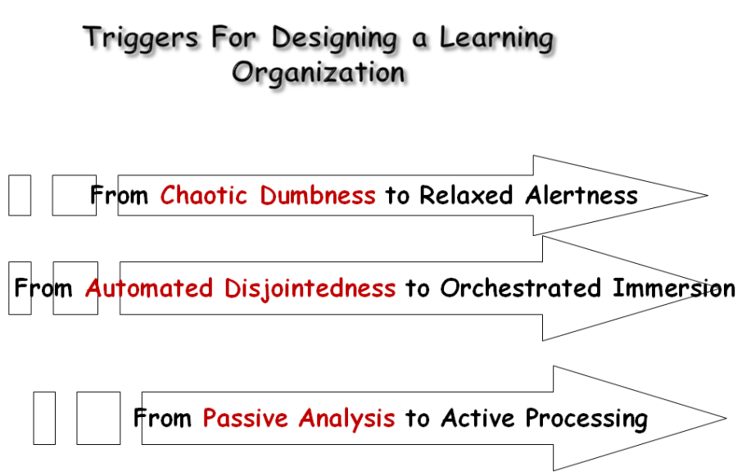
The starting point really is to understand and analyze value that each path can create. In any organization, term value is emerging as a focal point.

Before the release of a recent Bollywood movie, the Director giving an interview on the Television told that the movie has been shown to “interest groups” chosen from the target audiences of the movie. Further, some of their feedback, comments and suggestions have been taken up to change the movie. If we extend the trend - the director, writer and producer could have brainstormed with the group much before the movie started. The concepts of various story ideas could have been discussed with potential viewers and they could have been part of the process from the beginning. Better still, there could have been partial brainstorms, feedbacks and discussion sessions during the movie making so as to adapt the movie as per the inputs. This is the age of co-creation. The dawn of the age may be signified when “interactive movie production” becomes the new reality. This is after “interactive TV” and “interactive story writing” on the Internet is becoming a reality. The individual in the new world demands continuous involvement in the co-creation. The new world demands, defines and develops new ways. These are not the bland ways of making the world flat – it is really about thriving in the melting pots of creative juices. Evolving the interactions, connections, the networks, and the chaos into rapidly moving and changing structures where the value is not in any fixed static structure or organization. The value lies in the dynamic of the structure. The new thriving, creative and ever evolving world demands new ways to capture value and create value.

Characteristics of Success in the new world

The new world demands connectivity as it feeds on connectivity. It demands freedom from all boundaries. It explains to us that the problems that we are facing need not be solved by us. The solution might already have been done in six billion plus population that is calling us for connecting. It asks us to connect to the rest of the world without thinking about any boundaries of language, time, trade, geography or race. It is remarkable that success is defined in this world only through a model of continuous leveraging of knowledge and connectivity. These are the fuels that empower an individual to create, recreate and reshape his/her destiny as well as give the power to redefine the world that we live in. This is an unprecedented capability. What it means is that ideas, solutions and success are not the prerogative of the select few. Success has transcended the whole gamut of human race and needs tools, techniques and methods to leverage minds that are distributed and may be hidden behind the artificial boundaries that we have inherited from history.

The globalizing world is increasing the interactions, dependencies, couplings or connections in not only the depth of existing dimensions but in increasing the number of connection dimensions manifold. The complexity of the new world is increasing as it is demonstrating the complex behavior associated with complex systems such as a natural organism or a natural eco-system. Dealing with this complex world needs new methods of study or solving problems. These methods need to be not only aware of but thrive and exploit very nature of complexity.

Global Innovation Complexity (GIX)

Global Innovation Complexity (GIX) is increasing as the globalization is rapidly accelerating - we call this the GIX Bang - on the lines of Big Bang. The GIX Bang is happening due to the three inherently coupled trends of increasing globalization, increasing complexity and increasing Innovation. However, these three are so intertwined with each other that one cannot have a model of GIX Bang. A model of GIX bang will involve explicit mapping of interactions between Globalization (G), Complexity (X) and Innovation (I). Let us look at the parameters that are impacting these three trends:

- G is impacted by connections (new ways of technological connectivity across the world), Value (economic, social, military, political, technological, human) across the globe that the connections are enabling, Global real time awareness that creates Ideas to increase globalization, Have-nots of the globalizing world are creating various barriers for controlling these connections which impact globalization adversely.

- X is increasing due to dependencies which are global, in multiple dimensions, and much deeper with multiple feedbacks that can create pockets of chaos and pockets of order in the world which leads to more and more of possibility of new - the emergence phenomenon that we all know about.

- I is the by product - the G and X interactions demand and will create Innovation - it is the only way for all of us
In the GIXBang world RAPID INNOVATION is the way forward, through a rise and rise of networked individuals and may be beginning the demise of hierarchies.
Navneet Bhushan (Navneet) is a founder director of CRAFITTI CONSULTING (www.crafitti.com) – an Innovation and Intellectual Property Consulting firm focused on co-crafting Innovation in global enterprises. He is the principal author of Strategic Decision Making- Applying the Analytic Hierarchy Process published by Springer-Verlag, UK, as part of the Decision Engineering Series. Navneet Blogs at http://innovationcrafting.blogspot.com. He can be contacted at navneet(dot)bhushan(at) crafitti(dot)com

