The Ladoo Game and Indian IT Companies

The Ladoo is one of the most common sweet across India. In fact, Ladoos are distributed in India on almost every religious or social milestone of an Indian family. There are many metaphors in our language and our culture which use Ladoo to convey deeper meaning in less number of words. For example, marriage is considered to be a Ladoo – one who eats it is also repentant and one who doesn’t eat is also repentant. I have designed a simple game using the Ladoo metaphor and has been using for last 7 years in multiple workshops and innovation classes to explain why people and hence companies get into a complacency mode and also to find out entrepreneurship or innovation potential of people.

The Ladoo Game
All of us have various choices available at every point. Sometimes, we may have to create new choices. Usually we pick alternatives from available choices. There is a theory of rational decision making which says the human mind computes/calculates some sort of expected value of the choices in terms of benefits to pick up an alternative from available choices.
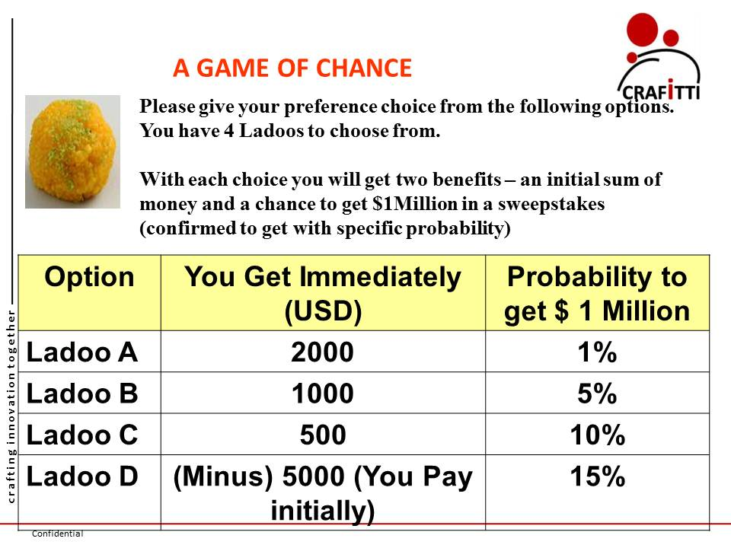
In the Ladoo Game you have 4 different Ladoos to choose from. You have to pick only one of the Ladoo as shown in Figure. Every Ladoo gives you two benefits – immediate hard cash in your hand and a probability to get $1 Million in a Lottery. The probability varies from 1%, 5%, 10% and 15% for Ladoo A, Ladoo B, Ladoo C and Ladoo D respectively. Also with increasing probability of you getting $ 1 Million, the hard cash amount goes down from $2000 to $1000 and $500 from Ladoo A to Ladoo B and Ladoo C respectively. However, in Ladoo D, with increased probability of getting $ 1 Million, you have to pay $5000 instead of you receiving initial money.
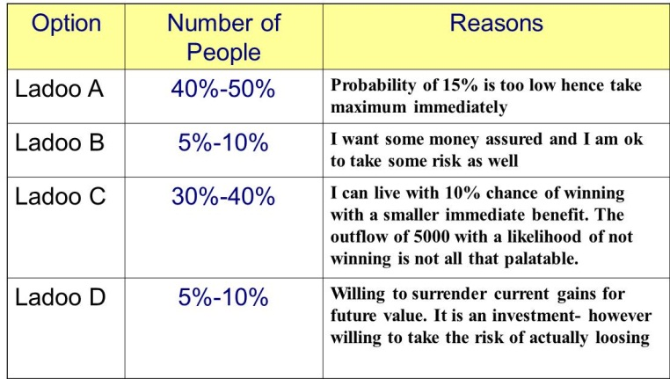
In multiple workshops with engineering and business students, as well as, companies across domains in India, we have found that 40%-50% of the respondents choose Ladoo A while 30%-40% choose Ladoo C. Only 5-10% opts for Ladoo B or Ladoo D.

The Rationalilty Theory tells us that the expected value of an alternative is the difference of expected Gains/Benefits and investment. Applied to all Ladoos this amount to Expected Value of a Ladoo = Probability x Prize + Initial Gain or ( - Initial investment).

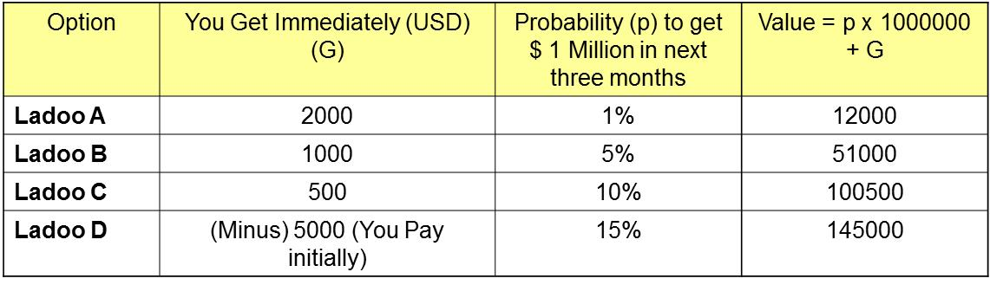
For the 4 Ladoos we have the following rational calculations of Expected Value for each of 4 Ladoos. The Rational Value theory tells us Ladoo D will give the maximum gains, however, human beings give different weights to different parameters hence the variation in real life responses.

- Ladoo A guys are saying – Let me get what I am getting now (2000 USD) I know whether it is 1% or 15% it is same – I will not get it!
- Ladoo C guys want to get maximum of both sides – certainty and uncertainty – thereby saying I will not give anything from my pocket (- USD 5000) but still would like to maximize the probability of getting USD 1 Million in the sweepstakes. The optimization experts.
- Ladoo D is the rational value follower with objective analysis he follows the rationality based on mathematical analysis or pure intuitive perspective of going for prize with whatever it takes. He is taking calculated Risk.
- Ladoo B is the most perplexing! (may be caught in between A and C)

If one asks, who will you choose to run your business, you would like to hire Ladoo C guys. These are going to focus on optimizing your business. In a world that is predictable to a great extent and the speed of change is moderate to medium, these may be the best alternative. However, in a world which is going through massive high speed changes in multiple dimensions, where uncertainty and change are the norms, only Ladoo D guys can give you options of thriving in the change as they are ready to invest to create the desired change.

Indian IT Companies missed Ladoo D
One point that emerges from Ladoo Game is that companies that are getting Ladoo A regularly will find it difficult to invest for Ladoo D – even if the rational value analysis says D is better. Obviously, if you are regularly winning in a game using certain tactics or methods, you would like to repeat the same winning methods. The problem is if the game is changing, rules are changing or different players are coming in, you may have to rethink your strategy. However, all the above factors are changing simultaneously; you have to move to a position of defining and creating the game rather than playing the game. In that scenario, you need to opt for Ladoo D.

The Ladoo D option of investing in creating the next has been missed completely by Indian IT companies for last decade or so. Results are visible now. The people, managers and leaders who came with a mind of Ladoo A or Ladoo C, are suddenly required to choose Ladoo D. This requires a different mindset and different system of being a creator rather than being one more cog in the global IT optimization machine. The Indian IT Leaders need to choose Ladoo D and define the world that they want to be in. This requires a shift to “creating” the new rather than optimizing the existing.

Even now, with the money available with Indian IT companies – it will be more prudent to invest in Ladoo D and aim for Jackpots rather than try to scavenge Ladoo Cs options from players who are defining and creating Ladoo Ds.

Navneet Bhushan (Navneet) is a founder director of CRAFITTI CONSULTING (www.crafitti.com) – an Innovation and Intellectual Property Consulting firm focused on co-crafting Innovation in global enterprises. He is the winner of Indira India Innovation award for Entrepreneurship and Innovation Leadership for 2012. He is the principal author of Strategic Decision Making- Applying the Analytic Hierarchy Process published by Springer-Verlag, UK, as part of the Decision Engineering Series. Navneet Blogs at http://innovationcrafting.blogspot.com. He can be contacted at navneet(dot)bhushan(at) crafitti(dot)com

