What Ails Indian IT Companies – A View from Software Innovation Triangle

Indian Information Technology (IT) Industry is going downhill. As is usual, the companies will look at outside factors. However, if they think little more, one very strong reason is that the large IT development companies are looking at “how to develop software” and “how to evaluate software”, only. There is another key question which is “what software to develop?” Specifically, Indian IT companies are focused predominantly on how part of software innovation triangle. Indian IT companies need to focus on “what” part of the software innovation triangle, as it not only has more value but it is that leg that one can protect by ways of IP rights as well.

The Software Innovation Triangle - One What and Two Hows

Software has been defined as instructions and data structures (computer programs) that when executed on a machine provides desired function and performance along with documents that describe the operation and use of programs.
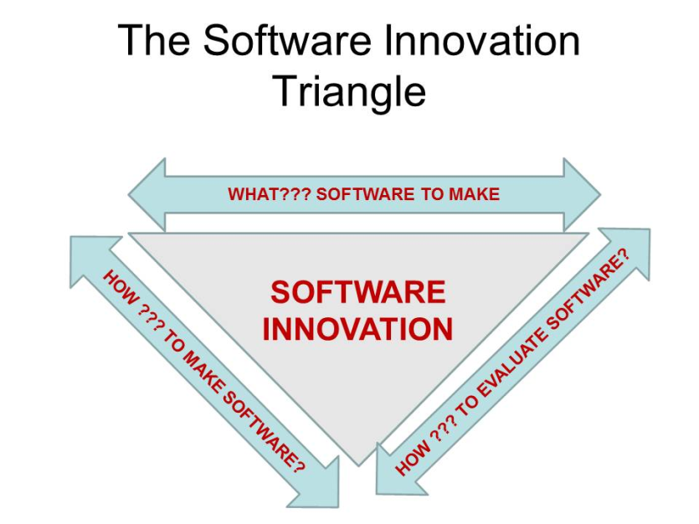
A very useful definition of innovation is successful creation of change by (new) ideas. Combining the above, software innovation has to be successful creation of change by new ideas in developing computer instructions, data structures and associated documents. This should include how to develop software, how to evaluate software and also what software to develop to achieve desired functionality and performance to meet a need or set of needs. I call this the software innovation triangle – the two “how’s” and one “what” of software innovation.

Typical Application Maintenance (AM) Projects

if one looks at a typical application maintenance (AM) project/program - the "bug-fixing" jobs - that constitute more than half of Indian IT Jobs on which these companies have built their campuses and brand value, the process efficiency (a metric of how much "end-value" adding time as a percent of total time spent ) is around 35% or less. It means 65% time and effort is wasteful. It was but obvious that technology solution would be needed. A cloud based model is current possibility. Very early an interesting model by Microsoft has been proposed. When MS Office crashes - there is a pop-up application which seeks permission of the users to report to Microsoft the bug. A patent was also granted to Microsoft in 2003 on that application. Logically these solutions - such as application that captures the memory offset on a failure - should have been developed and protected by Indian IT companies. Same is true for cloud computing models. But given the "intellectual vacuum" of Indian IT top leadership - and a focus on billing rates and billability of the head count - we lost an opportunity to possibly define the future. It’s a loss.

Indian Information Technology (IT) companies should have understood and seen this coming in early last decade itself. Instead of planning and executing the next wave - they simply paid lip service to (a) creating, owning, protecting and monetizing their intellectual property (b) Making products as the basis of future growth (c) building a real R&D base (d) defining the next wave instead of following others (e) moving away from billing rate based - "body shopping" model. Leadership of these companies should be blamed - as they continued to be followers and fulfilling their US client-masters by providing the so called "cheap jobs" instead of "Steve jobs". However - we still can act in vectoring our resources, energies and capabilities to define the future - not in terms of creating more jobs but creating more capabilities to build the nation!! A deep focus on science, technology, engineering and product creation is needed! Let’s hope we will create the future that we define.
Navneet Bhushan (Navneet) is a founder director of CRAFITTI CONSULTING (www.crafitti.com) – an Innovation and Intellectual Property Consulting firm focused on co-crafting Innovation in global enterprises. He is the winner of Indira India Innovation award for Entrepreneurship and Innovation Leadership for 2012. He is the principal author of Strategic Decision Making- Applying the Analytic Hierarchy Process published by Springer-Verlag, UK, as part of the Decision Engineering Series. Navneet Blogs at http://innovationcrafting.blogspot.com. He can be contacted at navneet(dot)bhushan(at) crafitti(dot)com

